Z-Fever, Inc
4607 N Lois Ave, Tampa, FL 33614

Differential / CV / LSD / HP / Torque / R160 / R180 / R200 / R230 / Diff Mount FAQ

This question is extremely common and has no perfect answer, but this post is intended to relate what is typical amongst Hybrid Z'ers. A couple of basic points to start with:
1. Torque kills diffs, not hp.
2. The heavier your car is, the bigger diff you should get
3. When you spin one tire in your car because you don’t have a limited slip, the side and pinion gears inside the carrier, aka spider gears, are moving really fast to allow that one wheel peel to happen. THE MOST FREQUENT CAUSE OF FAILURE IN OUR DIFFS IS RELATED TO THE SPIDER GEARS.
4. On the Nissan diffs, ring gear size is given in mm.
R160 = 160mm or 6.29” in diameter
R180 = 180mm or 7.08” in diameter
R190 = 190mm or 7.48” in diameter
R200 = 200mm or 7.87” in diameter
R230 = 230mm or 9.05” in diameter
SPIDER GEAR FAILURES EXPLAINED:
What we tend to see most often is that the cross pin which holds the spider gears comes loose by breaking it's retaining pin. When this happens the shaft can then move back and forth and will eventually wallow out the hole in the cast iron carrier. This causes misalignment of the spider gears which makes the gears grind on each other and puts a lot of metal shavings in the oil. As the gears wear on each other and get looser the pin gets looser. Once that happens the pin works its way out of the carrier and starts beating the inside of the case. Sometimes the pin breaks in half, sometimes it just bends, but that's the end of the differential. This problem is pretty well known in drag raced, open, 2 pinion carriers. Welding the diff or switching to an LSD generally alleviates this problem.
Here is a list of available diffs that you might (relatively) commonly find in a Z:
R160 - Originally came in 510s, Subarus. Lighter weight than stock Z diff
R180 - Came in 240, 260, 77-78 280Z automatic, and 280ZX automatic, among others. Also in the new WRX STi
R190 - Nissan Comp diff used in early 70's race cars and 432R's. Still some of these floating around.
Longnose R200 -weight 76 lbs - Came in 260Z 2+2, 280Z manual, 75-76 automatic and 2+2, S130, Z31, 200SXT
Shortnose R200 - weight 72 lbs - Later model 240SX, Q45 1989-1996, R32 Skyline, 300ZX NA, 350Z
Shortnose R230 - weight 114 lbs - 300ZXTT, Armada front diff
Straight axles - Ford 8.8", Chevy 12 bolt, Ford 9"
WHICH ONE IS BEST FOR YOU AND WHAT DOES IT TAKE TO PUT IT IN?
The R160, R180, and R190 are straight bolt ins to any 240Z. The diffs are all the same length from the axle to the rear cover. None of these diffs require a different mustache bar.
The R160 is only a 6.3" ring gear, so it is quite small. The open diffs are susceptible to spider gear damage due to spinning one tire. Still, 510 guys have been putting this diff, especially the clutch LSD version out of mid to late 80s Subaru XT turbos, behind big motors for a long time with good results. Gary Savage reported using one of these for more than 10 years in his VG30DET 510 which had 300 ft/lbs torque at the wheels.
The R180 is the standard diff in any 240Z. The ring gear size is 7.08”. The open diffs are susceptible to spider gear damage due to spinning one tire. While we have had members run 300+ hp and 260+ lb/ft of torque through these diffs in road racing applications, they are not commonly held to be particularly strong especially when the open version is used. One more pitfall here is the 2 pinion LSD. This “street” LSD uses 2 pinions instead of 4 like the “comp” version, and it is extremely fragile. The 4 pinion LSD is much more stout and the 2 pinion should be avoided if possible. V8 and big torque cars can use this diff on the street but it is not recommended for drag racing.
Newer R180s are availabe from the 84-88 200SX and have a large K cast into the top of the housing. They can be used in the Z with some modifications. The newer diffs use a stub shaft that plugs into the diff and is retained by a circlip, and the older diffs used a bolt in stub shaft.
CLIP IN AXLE VS BOLT IN AXLE R160s/180s
There are two ways to use the newer R180s with the original side stub shafts and half shafts. One is to convert the diff to the bolt in axles. The part that the bolts connect to is called a button, and the procedure to swap the buttons into a K diff is described below. These same procecures hold for LSD carriers, but the disassembly of the LSD is a bit more complicated. The other is to modify the stubs to use a spring clip, and then clip the axles in. www.betamotorsports.com has taken the effort out of this procedure by performing all the machine work. Just buy the new stubs and clip them in.
In addition to the bolt in axle issues, there is another difference between early and late R180s. Early R180's measure 110mm inside the ring gear. 77 and later model year R180s measure 115mm inside the ring gear. This minor change means that the ring and pinions won't swap between the early and later models. If you have an early diff you must use an early carrier, and if you have the later diff you must use a later carrier. It is possible to use a early carrier on a later ring gear with a spacer, but that is outside the scope of this thread.
Modification procedures to convert new K R180 to bolt in stub shafts:
1. Start with K R180:
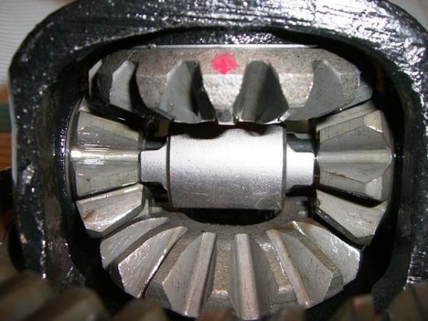
2. Remove seal protectors and circlips:
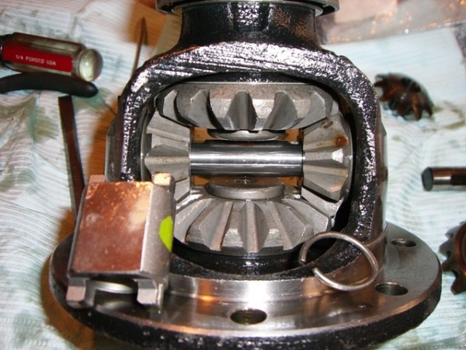
3. Remove buttons from side gears in old differential and place them on the new side gears in the K R180:
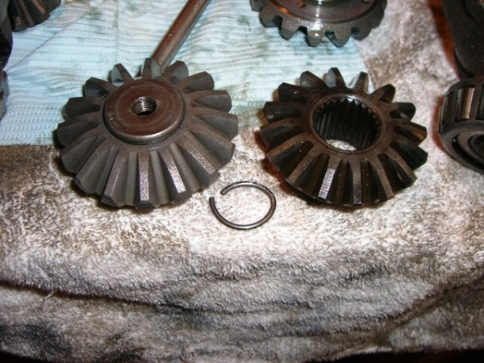
4. Reassemble carrier with buttons in place. Now you can bolt in the side stubs just as you would on the original R180:
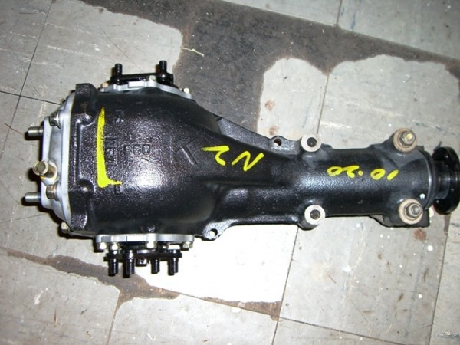
The R190 was a diff sold through Nissan Comp back in the 70’s and maybe 80’s too. It is a good option if you can find one, but they aren’t very common. They come in a 4 pinion open diff which is much stronger than 2 pinion open, and a 2 and 4 pinion LSD version. Again, avoid the 2 pinion LSD. The H190 Detroit locker also fits in this differential, but this is a really rare combo. The Detroit locker R190 would be great for a drag racer if it could be found. It does ratchet quite harshly on cornering though.
The LONGNOSE R200 is the diff that started to appear in the 260 2+2 and continued through the 280Z and 280ZX manual, and also came standard in all Z31 cars as well. Some 200SX’s also came with this diff, and probably others. This diff is strong enough for most Hybrid Z cars, and is by far the most popular swap. All of the 280Z and ZX’s and 200SX’s came with 2 pinion open diffs. These of course suffer the same weakness as the previous diffs. 87-89 300ZX Turbos came with clutch LSD’s (CLSD). The Nissan CLSDs are all 4 pinion, and the pinion gears are very strong in the LSD. There have been complaints that the CLSD would start to slip like an open diff with more than 300 lb/ft of torque. This seems to be a problem with the clutch pack design. In order to save money it appears that the clutch packs were skimped upon, using a thick solid washer to make up a large portion of the clutch pack thickness. The result is that the tabs on the few clutches that are actually in use will break under heavy drag racing use. Some (only some) Nissan Comp diffs have a better more complete clutch pack, but how exactly one determines which have more clutches and which have fewer has yet to be determined. There has been at least one case of a racer buying a LSD from Nissan Comp and getting the shoddy clutch pack setup. Some members here have gone to the trouble to make their own clutches to replace the spacer in the LSD, which should provide a lot more strength for high torque applications. There is also a viscous LSD (VLSD) which came in the 88 SS version of the 300ZXT. This is a rare diff indeed and the spline count of the LSD unit is different than the CLSD or open diffs, so if you buy one, best to be sure you get the original CV’s with the diff.
The R200 is wider than the stock R180 diff that comes in the 240Z, but most people use the stock halfshafts when they swap this diff in. This can lead to the halfshafts bottoming out which can cause handling issues. For more info read the R200 Handling Issues link here: http://www.betamotorsports.com/benchracing/index.html The solution here appears to be to use the CV joints from the 300ZX Turbo when installing into a 240Z.
The parts list needed to bolt in a longnose R200 into a 240Z is as follows:
1. mustache bar from 280Z with R200
2. yoke (companion flange) from 280Z with R200
3. rear cover from 280Z or ZX with R200
4. side stub shafts from 280Z or ZX with R200 to bolt up to stock halfshafts
FOR EARLY 70-71 Z's only, you need 5 -7.
5. Longer 72-78 driveshaft
6. Curved transverse link that sits right behind the diff from 72-78 Z
7. Flip front diff mount around on crossmember
5-7 are necessary because the early Z's had the diff mounted forward, and swapping to the R200 moves the diff rearward. Obviously if you buy a diff from a 280Z with an R200, it has everything you need except the mustache bar. If you buy the 300ZX diff, then you need the above pieces.
Here are some more resources for the R200 swap: http://zhome.com/ZCMnL/tech/R200.htm. www.zbarn.com sells a kit containing all the parts necessary to do the swap. It's part number is DT1299.
Another option is to convert to CV shafts. If you do that, then you need the CVs from the Z31 300ZX Turbo along with an adapter, and you no longer need #4. Adapters are available from www.modern-motorsports.com. There is also a way to convert to 280ZX Turbo CV's as well. These aren't as strong as the later CV's. Modern Motorsports has those adapters as well.
It is also possible to modify the rear transverse link to clear the finned cover of the 300ZXT rear cover. This requires a bit of fabrication, but is pretty easy and has the advantage of a larger sump and cooling fins to allow the diff to run cooler. If you do this then you don't need #3.
The longnose R200 diff has been used for extremely powerful drag racing cars, all the way up to 9 second ¼ mile times, but it seems to be generally accepted that you can run 400 + lb/ft through them without any damage, except clutch damage in the case of the Z31T clutch LSD.
The SHORTNOSE R200 and R230 are entirely different from all of the above diffs. They are very similar with regards to installation, so we’ll deal with them together. These diffs are as the name implies shorter, and so THESE ARE NOT A BOLT IN. The shorter length will require a new longer driveshaft. Most people buy this diff for the viscous LSD. While VLSD’s are not as aggressive as CLSD’s, they are fairly bulletproof, and don’t have issues with clutch packs breaking. They are also much more readily available in the junkyards than the 87-89 Z31T longnose R200 with LSD. The open diffs have 4 pinion carriers so they are also more durable than an open 2 pinion diff, but the decision to go through all the hassle just to install a 4 pinion open diff would be questionable at best.
Installation of this diff is not for the faint of heart. It takes lots of fabrication to get this install completed. The mustache bar must be redrilled for the wider stud spacing on the short nose diff cover. This sounds easy, but the mustache bar is made from super hard spring steel and is very difficult to drill holes in. Most people take the diff to a machine shop to have this done. Then the diff must be spaced forward to clear the uprights for the rear suspension. The longnose cover does not bolt on, so it cannot be substituted.
The differential won't clear the link between the two rear control arm bushings. A custom link can be made, or this piece from www.arizonazcar.com can be used. It moves the brace between the control arm bushings up and out of the way:
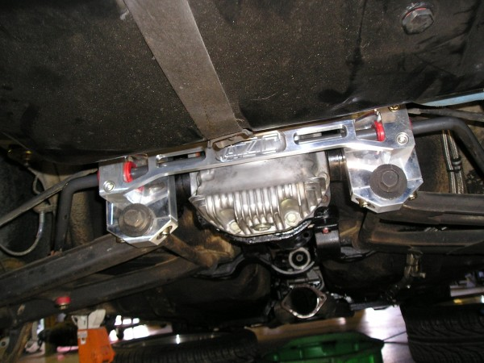
The front mount is entirely up to you. Several parts suppliers have expressed interest in making a custom front diff mount for the short nose R200, but none has done it as of this time. Most people modify the original short nose front diff crossmember and use it. This is commonly done by building a cradle or frame that attaches the front S30 diff crossmember in front and the transverse link just inboard of the rear control arm bushings in the back. This is a simple ladder type frame and the original front crossmember is trimmed to fit into this ladder and welded in place.
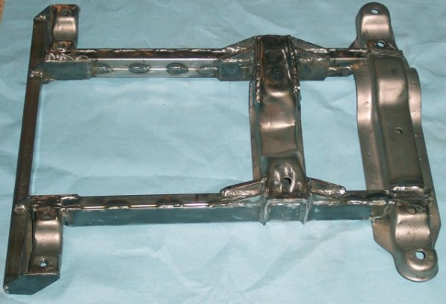
Another way to mount the diff is to build a frame that sits over the top of the diff and attaches the chassis of the car. The frame then bolts to the stock bushings on the front of the diff. Here's an example:
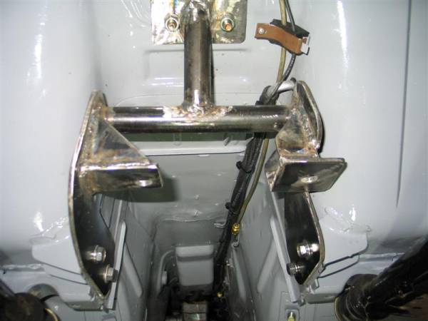
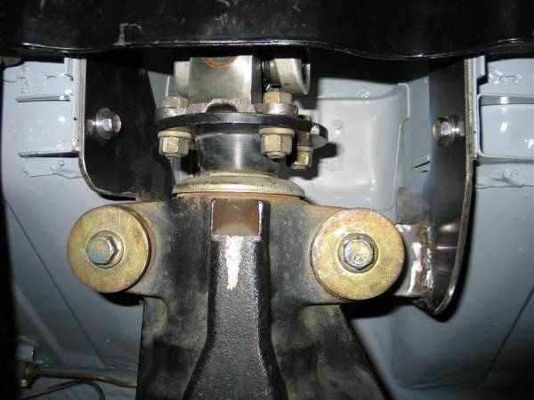
Either way you’re into some pretty serious fabrication, and due to the torque multiplication of the diff, the forces on this front mount can get EXTREME. There can be thousands of pounds of upward force on the front of the diff that the mount has to transfer to the chassis. This is not a job for a first time welder.
The CV shafts from the donor vehicles are too long to use in the S30 chassis, so custom CV shafts must be used. In order to get one set of CV shafts, it is necessary to obtain 4 inner CV shafts from an Infiniti Q45. If you are junkyard shopping, that means you are most likely going to buy 4 Q45 shafts, and throw away the shafts and the outer CV joint. Once the 4 inner shafts are obtained, a new shorter CV shaft is necessary. Moser makes this piece and it is available through www.modern-motorsports.com. Modern Motorsports also makes the necessary adapter to bolt the CV shaft to the companion flange at the wheel side of the CV shaft. Modern Motorsports has ensured that the shafts they sell fit both the R200 shortnose and the R230 shortnose, so there should be no issues with bottoming the shafts out or topping them out with either differential.
The Modern Motorsports CV shaft assembly:
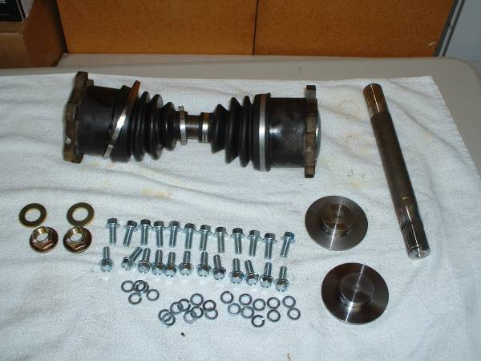
The torque capacity of the shortnose R200 should be equivalent to the R200 longnose, which means it can handle a lot of abuse. 400 lb/ft should not be a problem with the R200 shortnose, and it will probably hold a good amount more if the VLSD is used. There is apparently another model of the R200 shortnose which has 5 bolt output flanges on the sides of the diff. This model should be avoided, since the CV adapters we have available use the 6 bolt flanges.
The R230 is bigger than a 9” Ford differential, so we’re talking HUGE torque capacity here. I suppose we’ll have to wait for someone to break one before we’ll know for sure.
BACKHALVES/LIVE AXLES
With straight axles the sky is the limit with regards to torque capacity. Installing a straight axle in your Z is not a bolt in proposition and requires a lot more fabrication than the R200/R230 shortnose diffs. In brief and general terms, the procedure is as follows. The entire rear frame is replaced with a new rectangular tube frame. From this generally coilover springs and shocks are used to connect the frame to the differential. Then a linkage system is used to control the motion of the differential as the suspension moves up and down. The most popular of these is the 4 link, and this can be used in conjunction with a Panhard bar or alternatively a Watts linkage to locate the diff side to side. The benefit to going to a backhalf setup is nearly unlimited ability to build it up to hold more torque. Also the rear end can be “tubbed” which means that the rear wheel wells can be made much larger in order to accommodate huge drag racing slicks.
Live axles were also fairly common in road racing Z cars in the GT2 category. This is because they could be had with a quick change rear end, allowing for gear ratio changes to suit a particular track without having to pull the entire differential out. Also there used to be a fairly severe weight penalty in the GT2 class for running independent rear suspension. Now that penalty has been reduced so it is likely that live axles won’t be as popular in the road racing Z cars of the future.
LIMITED SLIP DIFFERENTIAL CARRIERS
What are they, how do they work, which one is best? Here’s a brief rundown:
Nissan Clutch LSD: This is the most common type of LSD for R160, R180 and longnose R200 diffs. Nissan sells them through Nissan Competition Dept and NISMO. This is a 2 way limited slip, meaning that it limits slip both on acceleration and deceleration. It is torque sensing, and the more power you put to it the harder it locks up.
R160’s use a 3 pinion design and is generally regarded as very strong.
R180’s come in a 2 pinion and a 4 pinion version. The 2 pinion is weak and prone to breakage. The 4 pinion is very strong.
R200’s come in a 4 pinion version only, but there are several different clutch packs. It appears that the Z31T diff from the 87-89 300ZX Turbo came with a large spacer to take the place of several of the clutches in the stack. With powerful engines and slicks this can lead to stripping the teeth off of the clutches, making the diff no better than an open diff. NISMO and Nissan Comp sell another version which has more clutch disks and no spacers that should be a lot stronger, but there is some ambiguity as to what you will get when you order one. At least one person has reported buying an LSD from Nissan Comp and getting the spacers. The better diff with the improved clutch packs also has more aggressive lockup. One way to tell the two apart is to look at the ramps and the cross pin shaft shape.
This is the better more agressive unit, note the obtuse angle of the top and bottom of the cross pin:
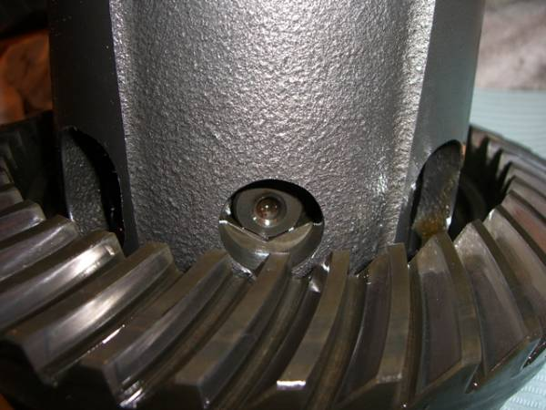
This is the one with the large spacer in it, note the almost square ends:
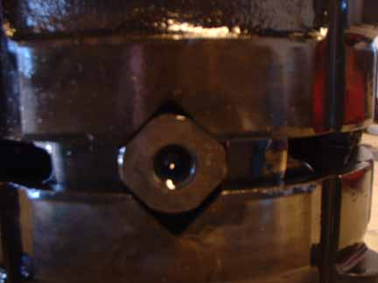
Power Brute - This LSD is the same as the Nissan unit, and is imported from Japan. It is distributed by www.differentials.com and www.reiderracing.com, but again which version of the R200 diff you’ll be receiving is somewhat ambiguous. Get the good clutch pack if you can.
Quaife - This is an entirely gear driven LSD. The way this works is that the side gears drive long pinion gears into the sides of the case. As long as there is traction to both wheels the pinion gears get driven into the case, and the friction from that action transfers the torque from one wheel to the other. This torque transfer can be measured and is frequently referred to as a torque bias ratio. The R diffs have a torque bias ratio of 5:1. Amazingly this diff is warranteed for life, even if the car is raced. The Quaife is a one way diff and does not lock up on decel.
OBX - Chinese knockoff of the Quaife. Some other car forums had reported manufacturing errors. Still in business?
PHANTOM GRIP - The Phantom Grip is an inexpensive part that converts an open diff to limited slip. The way this one works is it has two plates that slide in between the side gears of your open differential. In between the two plates are springs. The springs push against the side gears, and this makes it harder to rotate the side gears. The strength of the springs alone determines the amount of lockup, there is no torque sensing function in this one.
TORSEN - This LSD was available for a short time and there are just a few of these floating around, seems like most/all are for R200s. The Torsen diff is a gear driven LSD like the Quaife, but the one used in the Nissan diffs is designed in such a way that it is more like a 1.5 way and does provide some amount of lock up on decel. There have been reports of a new Subaru being fitted with a R200 torsen diff, and also it seems the S15 version of the 240SX has a Torsen as well, so we may be seeing more of these diffs hitting the market at good prices soon.
Torsen LSD:
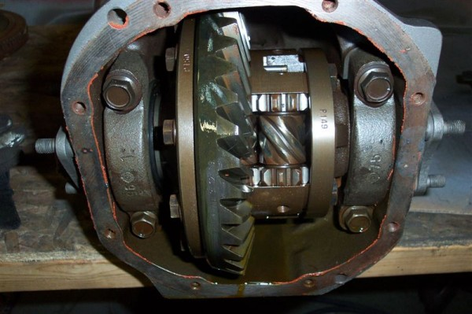
NISSAN VLSD - Viscous LSDs are commonly available in the shortnose R200 and R230. They did also make an appearance in the 88 SS version of the 300ZX Turbo. The limited slip mechanism is passive meaning that it is not doing anything to limit slip until one wheel starts to spin. A brief description of how it works is to compare it to a viscous coupling like that in a torque converter. The faster one side wants to spin, the more the viscous coupling locks the two wheels together. VLSD’s are not as grabby when they lock up and they aren’t as positively locked either. In road racing applications the fluid can overheat and cause slippage. The fluid used in the coupling is independent from the rest of the differential oil and it can be changed in viscosity to affect the aggressiveness of the unit.
KAAZ/CUSCO – These Japanese aftermarket parts manufacturers both make LSDs for the R diffs. They are commonly advertised for the 240SX which uses a shortnose R200, but the LSD can be used in a longnose R200 as well. If you purchase one of these diffs, make sure you get the replacement for 240SX with an OPEN DIFF. This will have the correct spline count for stock side stub shafts or Z31T CV shafts.
Both KAAZ and CUSCO produce LSD’s in 1.5 way and 2 way variations. The 1.5 way doesn’t lock the rear wheels together as hard under deceleration as it does under acceleration. This makes the car easier to handle when on the brakes hard. The clutch packs on these diffs are very impressive. They have a lot more and a lot larger clutch disks in them than the Nissan diffs so they should be extremely durable.
ARB Air Locker - ARB makes a selectable locker for the R180 and R200. This is an air powered unit that turns the diff from completely open to fully locked at the flip of a switch. The lockers have been around for a long time and are very popular with the rock crawling crowd. This means that they should be extremely strong, and this differential would be an EXCELLENT choice for a street/drag car, because it could be driven around town with the open differential and then locked solid for the track, and then switched back.
CV VS HALFSHAFT
The stock halfshafts that you might use on your 400hp V8 conversion are the same units that came on a 69 Datsun 510 with a L16 pushing all of about 100bhp. That’s right. They are exactly the same. Surprisingly, they will withstand a hell of a lot of abuse, especially if the halfshaft angles are kept relatively mild. Preventing the suspension from compressing too far on hard drag race style launches and avoiding excessive negative camber are two ways to help keep the halfshafts alive.
In the 70 and 71 Z cars the diff was also mounted forward in the chassis. This means that there is another angle in the halfshafts. Nissan realized that this was causing vibration complaints and U-joint failures and moved the diff back until the halfshafts sat at a straight angle, curing this problem. If you’re planning on running a high torque engine in your early Z, it is a good idea to move the diff back to get the proper alignment on the halfshafts. Still the halfshafts are definitely the weakest link in the drivetrain, so if you’re pushing big power, or running real low, or have an extreme alignment, it’s a good idea to step up to something better.
The original halfshafts:
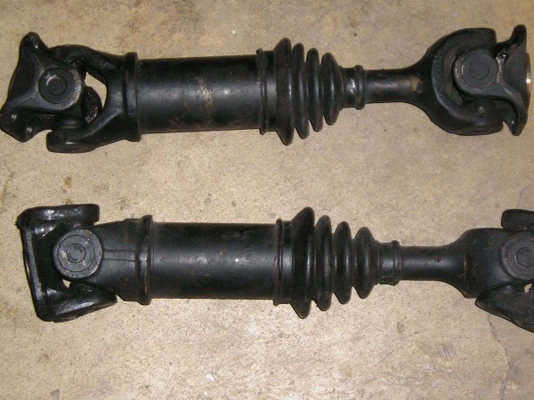
The CV shafts first made their appearance in the Z line with the 280ZXT. This car got the tripod style CVs which have 3 large rollers arranged 120 degrees apart from each other. The 280ZXT CV’s are more durable than the halfshafts and are a good upgrade. www.modern-motorsports.com makes an adapter which allows the CV shaft to be bolted to the companion flange on the stub axle (the wheel side connection for the halfshaft). The 280ZXT CV plugs into an open or CLSD R200. These CV joints have bulky housings and can interfere with rear swaybar end links. Some have simply put smaller end links on to get around this issue.
280ZXT CV shafts:
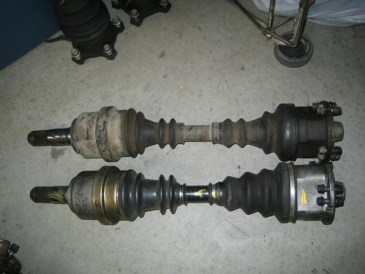
The Z31 got a different, stronger CV shaft. In addition to being stronger, the housing for the CV joint is smaller in diameter, and this means that it interferes with sway bar end links less. There are two different Z31 CV shafts. The normally aspirated Z31 uses a 6 bolt shaft. For whatever reason, these shafts are too long to be used in the S30 chassis. Don’t get NA Z31 shafts. The Z31 turbo shafts have 4 bolts, and they are the right size to fit into the S30, using companion flange adapters from www.modern-motorsports.com.
Z31T CV shafts:
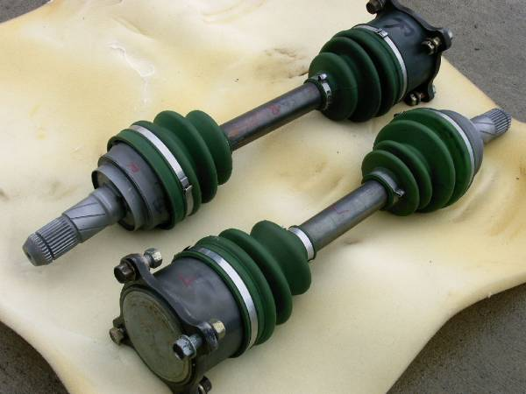
STUB AXLES
The stub axle is the part that the wheel bolts to, and has a shaft that goes through the rear strut housing and the wheel bearings. There is a “companion flange” which fits onto the splined end of the stub axle. This companion flange is the part which the outboard end of the CV axle bolts to. The stub axles are next in line to the halfshafts as the weakest links in the drivetrain. In most R200 configurations, the halfshafts will go out first, then the stub axles, then the diff.
240s have the weakest stub axles with a smaller diameter 25 spline shaft. 260s got the 240 stubs for the first part of production, then later got the 280s 27 spline shafts. The 240 shafts have been used by people running V8 conversions for long periods of time without any failures, but as with all of these things, usage will likely limit how long the weaker parts can be successfully used. In other words, if you are drag racing on slicks, you probably want to step up.
280 stub axles can be installed in 240 struts with no modifications and the wheel bearings and seals are the same in both cases. This upgrades the inner part of the shaft from 25 to 27 spline.
4130 STUB AXLES
Above and beyond the 280 stub axle swap, www.modern-motorsports.com makes a 4130 chromoly stub axle and companion flange in 4 or 5 lug styles. The companion flange can be ordered to fit the 280ZXT CV shafts, the 300ZXT CV shafts, or the shortnose R200/R230 CV shafts. This is the strongest option available without resorting to a live axle swap or making a custom strut housing to fit a larger beefier axle shaft.
Modern Motorsport 4130 stub axles:
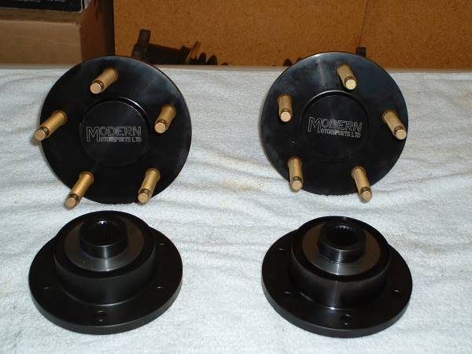
STUB AXLE FAILURE
Eric Neyerlin at www.zparts.com was nice enough to grant permission to show his photos of stub axle destruction. The stub axles usually tend to break on the inside where the compainion flange is. Usually when the stub axle breaks on the inside there is an odd noise similar to a broken U-joint that prompts the driver to investigate until the cause is found. The car may even still be driveable with the axle sheared in some cases. In other cases when the axle breaks the halfshaft falls away from the outside edge of the wheel and whips around beating the hell out of the control arm.
Picture of broken stub axle:
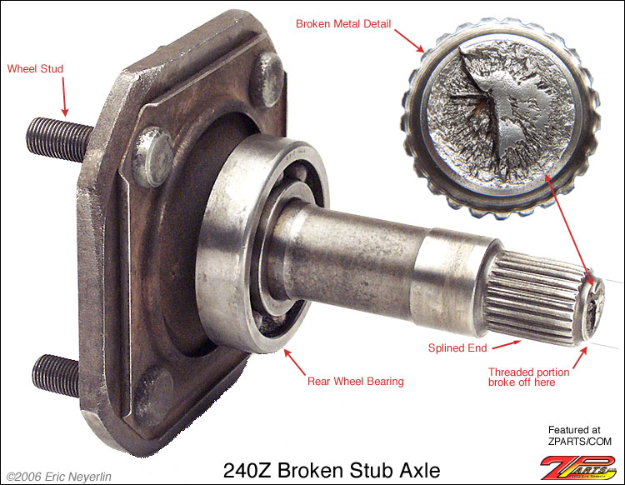
Close up of sheared edge:
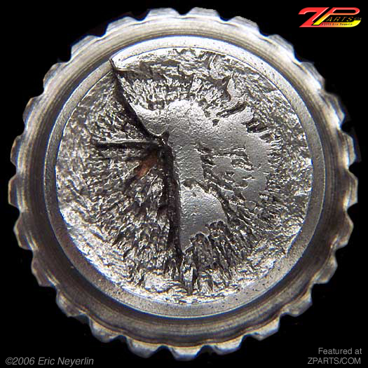
The other weld on the stub axle is located where the flange is connected to the shaft. If this part of the stub fails you're in trouble. The whole wheel and brake can lean right in until it hits some part of the suspension or wheel well. Here is a picture of what happens when the flange weld fails:
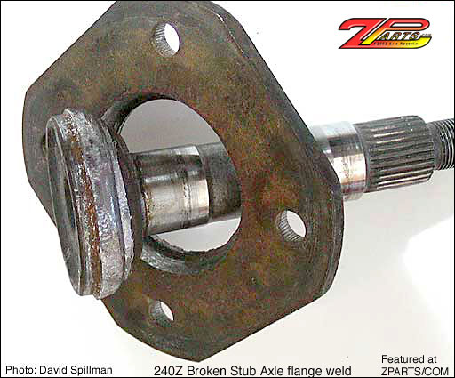
R160/180/200 LONGNOSE DIFF MOUNT
The stock front differential mount on the Z is a source of constant exacerbation for Z owners. The diff mount does not have a failsafe built into it so by design when the mount comes apart there is nothing to prevent the nose of the diff from climbing. Nissan was kind enough to “fix” that problem by adding a strap over the top of the diff which helps limit the lifting at the front of the diff. These two parts combined do a marginal job of controlling the diff even under the “abuse” that stock power levels can put to them. Any increase in power levels should be accompanied by some attention to the front diff mount.
SOLID DIFF MOUNTS
These are sold by several aftermarket parts suppliers including www.arizonazcar.com and www.zcarparts.com. They will absolutely prevent the nose of the diff from lifting, but they also transmit lots of noise into the cabin, so much that some members here have reported feeling physically ill after only 10 minutes exposure to the noise. Regardless of these issues, this is a popular race part for Z cars, and there are quite a few people who do use these mounts on the street.
ALTERNATIVE DIFF MOUNTS
The creativity of our members cannot be overestimated and some of the easiest and simplest solutions to this problem come from our members’ garages. Probably the simplest solution comes from Clifton, who welded two tabs, one in front and one in back, to the vertical face of the diff mount. Then he drilled a hole in the tabs and ran a bolt through the two tabs. The bolt is trapped underneath the crossmember, so the diff can only lift until the bolt touches the crossmember. Simple solution and easy to make. I could not find a picture of this diff mount. I know I've seen it before. If you have a link post it up please.
Another good one is the clamshell design. A U shaped piece of metal is fitted below the front diff crossmember, and a rubber pad is installed on the new piece. This is then bolted or welded to the existing vertical flanges of the diff mount, similarly to Clifton’s solution. The advantage here is that the rubber isolates some noise from transmitting through the bolt and into the cabin. It’s possible a piece of fuel or radiator hose over the bolt in Clifton’s design might have just about the same effect. Click here for pictures and an explanation of the clamshell design: http://album.hybridz.org/showphoto.php?photo=2501
Either way both are simple and well worth the effort.
There is also Ron Tyler's design, which is more like the pinion snubber that you would find on an American car with a solid axle. This piece bolts to the chassis and the mount hangs down, where the diff bolts to it. This works great because the nose of the diff moves UP when torque is applied so torque doesn't rip the mount apart.
Pros:
- It isn't solid, so you get vibration isolation ALL THE TIME.
- It allows the front of the differential to be lowered so that the minimum and acceptable driveshaft u-joint angles can be obtained for a JTR V8 swap.
- It allows you to modifiy/partially remove the front diff crossmember for mor exhaust clearance.
- It bolts right in (in most cases).
Cons:
- It requires welding.
- It may take some massaging to fit into certain early 240Zs? So it may be best to build it on the car.
- It uses no Nissan Parts? LOL
Here is a good thread on the Ron Tyler designed mount: http://forums.hybridz.org/showthread.php?t=95128
Here is a thread with very good info on solid diff mounts and the damage that may result from them, also shows good pics of the Ron Tyler mount: http://forums.hybridz.org/showthread.php?p=798627
ALL PICTURES WERE TAKEN FROM THE HYBRIDZ ALBUM. IF YOU DON'T WANT YOUR PICTURE USED, LET ME KNOW AND I'LL REMOVE IT.

