HOW TURBO’S WORK
Turbocharging forces compressed air into an engine to achieve improved engine performance and fuel efficiency, with reduced exhaust emissions.
The turbocharger is driven by waste exhaust gases, forced through an exhaust housing onto a turbine wheel. The turbine wheel is connected by a common shaft to a compressor wheel. As the exhaust gases hit the turbine wheel so both wheels rotate simultaneously. Rotation of the compressor wheel draws air in through a compressor housing, forcing compressed air into the engine cylinder.  The increase in air fed into the engine creates more combustion force and power. |  | 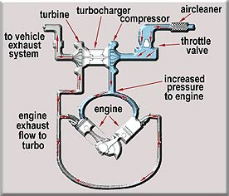
Turbochargers operate at very high temperatures, high speeds and high pressures. Optimum performance can only be achieved by the proper operation, maintenance and service.
Service Tips
- Make sure your turbo is serviced at the recommended intervals.  - Use only qualified and experienced specialists to service your turbo.  - Check out any oil leaks, excessive or unusual noise and vibration as soon as they occur. |  | 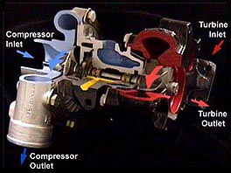
- Lack of power, excess noise, black
and blue smoke are more likely to indicate engine problems, than turbo problems.
- Wait for the engine oil to reach normal operating temperature before "revving".
- Let the engine idle for a couple of minutes before switching off.
NOTE: All names, numbers, symbols and descriptions are for reference purposes only and do not imply that any part is the product of these manufacturers.

